PRIORITIZING TOOLS

Quick Priority Setting Tools:

1. Raise Arms - Go through the list of issues, asking participants to use their arms to signal whether they deem an issue to be high, medium or low priority for handling. Keep arms down for Issues deemed to be low priority issues, Raise arms half way up for medium priority items and all the way up for issues they consider to have high priority. The facilitator scans the audience and marks by the item the priority (high, medium high, medium, medium low, low) and moves to the next item.

If the facilitator suspects there might be disagreement, ask participants in advance of the exercise to provide some reasons that this should be a high or low priority. Call for raised arms after the discussion.

If there's large disagreement, ask people to give reasons for their evaluation so the group can think about it again. Then have group raise arms a second time (Note: this method is simple and quick and works well where there 's already a lot of agreement. But louder people can dominate even if they're a minority.)

- Multi Vote Technique - Use when you have a list of discrete items to prioritize. For example, titles from a consensus workshop. If it is just a random list, do an easel consensus workshop to cluster items that are the same. To determine the highest priorities for consideration, give participants dots to award as they choose. Review items to be considered with the group to make sure participants understand the item. Ask for advocacy statements for items people feel strongly about - "if you want to sway the votes - here's your opportunity". Let those people speak to their item.

Count the items. The number of dots to give is the number of items divided by 3 plus 1. (Example: 15 items / 3 = 5 + 1 = 6 dots). Participants can distribute their dots as they choose (including placing more than one dot on an item). Add up the dots each item received and report the results back to the group. Determine from the items that got the most dots and which items the group wants to take to the next level of development - such as action planning. Make sure that the group is willing to take action and determine next steps.

The multi vote technique can be repeated if additional winnowing is needed, using the same formula on the reduced list to determine the number of votes to be given.

Priority Setting Techniques for More Complicated Issues

- Dot Voting With Criteria - Use with a list of discrete items/issues. The items can be displayed on chart, on cards on the sticky wall or a pre-made template with room for dots to the left of each issue. Review the list to make sure everyone understands each item and lead a discussion for understanding if necessary.

Give each participant three colored sticky dots, each representing different criteria. For example, red might represent major concerns with implementation; blue - items that are very important to the growth and sustainability of the strategy; and green - items that are the easiest to implement. Use the Multi Vote formula above to determine the dots (of each color) to give each person.

Participants are invited to come forward whenever they're ready and place their dots on the items. Participants place one dot of each color on the items of their choice.

Count the dots and report back to the group. Discuss the items in light of the information revealed by the criteria based multi vote and determine which items will be moved to the next level of strategy development.

(Note: we've listed this as a priority setting tool but it can be used in many ways - particularly good uses include for reflection, information gathering, etc.)

- Priority Matrix - Working from a visible list of items, rate each item on that item's level of impact (high or low) and effort required (easy or difficult). Place items on a 2 x 2 matrix - with high impact at the top and low impact at the bottom, easy on the left and difficult on the right. Position items in the matrix according to their level of impact and difficulty. Plan to do items rated easy to do-high impact, drop hard to do-low impact. High impact-difficult to do items can be assigned to teams. Low impact-easy to do items can be pursued by individuals who want to work on them. See additional detail on page 4.

- Interrelationship Diagraph - This approach is best when exploring a discrete list of issues (problems, contradictions, blocks) that have been discussed in detail with the group before starting before the exercise.

The purpose of the exercise is to determine which issues are driving the problem. Once the drivers are determined, the group knows which issues to focus on for resolution.

List the issues in a circle on a large sheet of chart or banner paper. Starting at the top and going in a clockwise direction (without skipping any item) compare the first item to the second item. Determine if these items are related. If they are related, determine which item is the driver (contributing to the existence of the other). Draw an arrow from the item that is the driver (flat end of the arrow) to the item it is influencing (the tip of the arrow). Proceed to compare the first item to the third item, repeating the above step, until the first item has been compared to every item in the circle.

Move to the second item and repeat the process, proceeding in a clockwise direction. When all the relationships have been established and the driver determined, count the number of issues each drives and issues each are driven by. Count the number of flat ends leaving an issue (the number of issues that item drives) and count the number of arrow tips (number of issues that impact that item) and note these by each issue. (Refer to specific directions on page 5.)

The items that drive the most other issues indicate high opportunities for focus. Facilitate a discussion to determine the next level of strategy development.

Setting Priorities Using a Priority Matrix

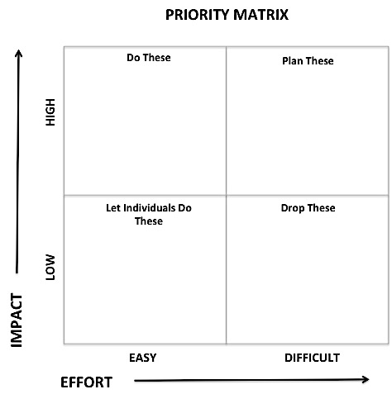
- Work from a list of items visually displayed on a chart or cards on the wall. Clarify all of the items so people know what they are discussing.
- Rate each item on:
- Impact - High or Low --- mark the item with H or L
- Effort - Easy or Difficult --- mark the items with E or D

Several ways to do this:
- Go through each item on the list for both effort and impact
- Go through the list twice - once for effort and once for impact

- Make a 2 x 2 matrix on a chart or a sticky wall with tape. The vertical axis represents IMPACT. High impact is at the top and low impact is at the bottom. The horizontal axis represents EFFORT. Easy is on the left and difficult is on the right.
- Describe the chart, then separate the items by their combined impact and effort: HE, HD, LE, LD.
- High Impact - Easy to Do (HE) are the low hanging fruit - these represent your best immediate strategies.
- High Impact - Difficult to Do (HD) are potential items for planning teams
- Low Impact - Easy to Do (LE) are items to delegate to champions who want to work on them.
- Low Impact - Difficult to Do (LD) should be avoided.
- Facilitate a decision-making conversation to clarify which strategies the group will implement.
- Make assignments and create planning teams plans for those strategies.
- High Impact - Easy to Do (HE): Break into action teams to plan these or make assignments directly to individuals.
- High Impact - Difficult to Do (HD) - Create planning teams and schedule the time for planning and implementation.
- Low Impact - Easy to Do (LE) - Delegate items to people who want to do them

INTERRELATIONSHIP DIAGRAPH

Purpose
To determine driving forces contributing to a problem in order to focus the resources which will be applied to the improvement.
Example:

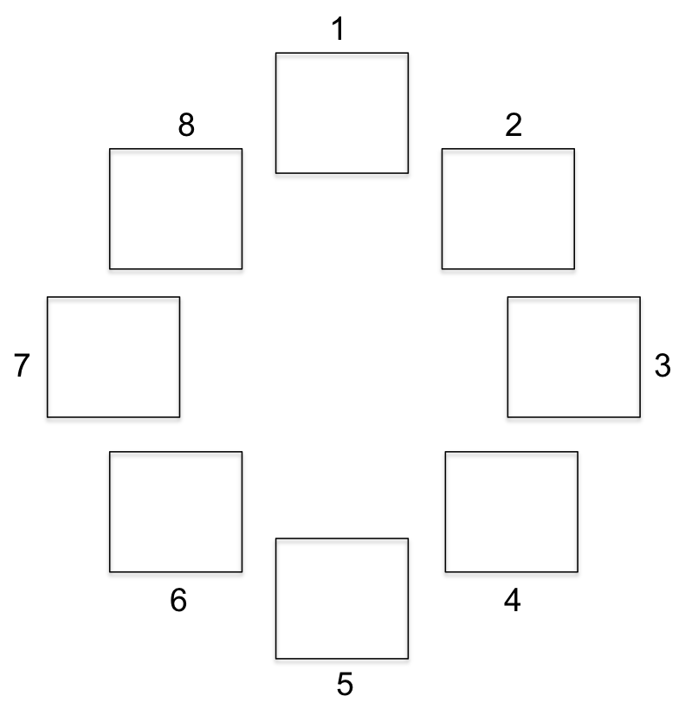
Directions
- Display headers from a problem sorting affinity diagram (titles from a consensus workshop) in a circle and number them clockwise (1, 2, 3, 4, etc.). (Draw boxes around them to make them easier to see.)

- Analyze relationships between header categories (Consensus workshop titles) working always in a clockwise direction (never clockwise).

- Ask two questions of each relationship between headers.
  - Is there a significant relationship between these two things?
  - If yes, which is the driver? (If no, do nothing and move on to the next header).

- Draw an arrow between the headers that have a relationship. Have arrow start at the driver box, with the point of the arrow touching the box being driven.
Example:
No Job
No Money

- When all relationships have been considered between all boxes, count the number of arrows leaving each box and the number entering each box and record as follows:

7 leaving / 3 entering - display as 7/3

- The left number ranks the strength of the driver while the right side ranks the strength of the one being driven by something else:
Example: | 7 / 3
 | Driver / Driven by

- Focus major resources on drivers to gain the most improvement on the problem

Source for the Interrelationship Diagraph and sample on following page: The Coaching Experience: A Transformational Journey
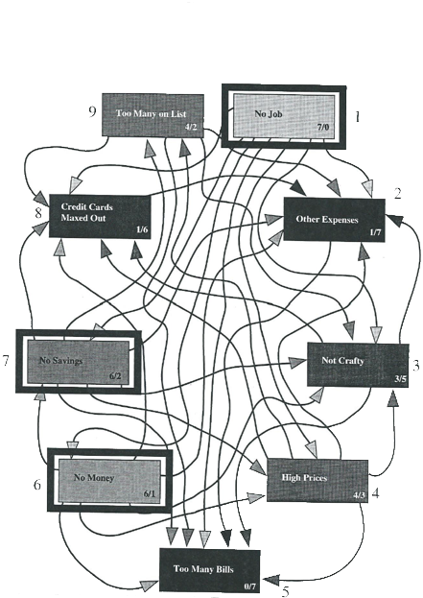
Sample Interrelationship Diagraph
Problem: Why can’t I ever afford Christmas shopping?

